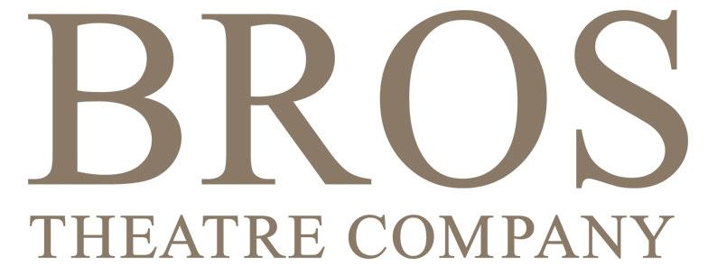

How-To Guide

Marketing manager

Role description in brief:

Manages general marketing activities to maintain a positive profile in the local community and to attract and retain members of BROS Theatre Company and specific marketing activities for the calendar of productions driving ticket sales for each show.

Main responsibilities:

- Build and maintain production marketing plans to drive ticket sales for BROS productions.
- Build and develop relationships with local organisations such as the RBRUT Arts Team, Local theatre management and local Arts events.
- Ensure effective, timely and appropriate communication to public and potential audiences.
- Ensure effective, timely and appropriate communication to members and potential members.
- Develop and maintain the BROS brand
- Manage member recruitment and retention activities.

Responsibilities in detail

Build and maintain marketing plans to drive ticket sales for BROS Productions
We have a baseline marketing plan that gives a standard structure of activities from about 12 weeks before show week. The marketing manager can use this as a starting point and discuss it with the production team before the show is in production. This discussion can help bring out key messages at specific times and uncover other marketing tactics that are specific to the production.

The marketing plan includes the following marketing activities:-

- Posters and flyers
- Email marketing
- Event Websites
- Merchandise
- Social Media ( according to plans from the Publicity and Social Media Manager )

Once the plan has been reviewed with the production team and actions have been allocated progress against the plan should be reviewed several times throughout the production. It is a good idea to agree the timings of follow up reviews at the first planning meeting so that dates/times can be firmly in the diary.

We also have a sales tracker which shows the progress of ticket sales for HHT shows - it’s quite helpful to see how a show is selling compared to other similar shows. Once sales have got started the sales progress can be charted and shared with the production team so that they know how sales are going.

Marketing manager should coordinate sign-off for various elements on the plan. For example flyer design/artwork concepts should be signed off by the committee and any feedback or necessary changes should be communicated by the Marketing Manager.

Special attention should be paid to the VPs on our database.

Build and develop relationships with local Arts organisations

This is really being the marketing point of contact for any involvement or partnerships that we have with other local arts organisations. You should request key contact information from the previous marketing manager. If we are working on projects with any of the local Arts organisations, you may need to provide copy and artwork for their marketing and publicity activities, and field questions between the local organisations and the BROS Committee members.. Organisations include:-

- The Barnes Old Sorting Office
- ArtsRichmond
- LBRUT Arts Team

Ensure effective, timely and appropriate communication to public and potential audiences.

Our outbound communication is generally via email and social media. Email marketing is carried out using mailchimp.

Our mailchimp database “master mailing list” is now 1182 and each person on the list is ‘tagged’ using groups. Our range of groups can change as required - currently the following tags exists for members (and a member can have more than one tag/be in more than one group)

Members - any current paid up member
VPs - any member of BROS who has been given lifetime membership for exceptional service
Alumni - any ex-member or attendee at a presentation, workshop or audition (not necessarily ever a member)
Member Enquiries - anyone who has requested information about BROS but has not yet joined.
Local Arts Organisations - contacts from other local Arts groups
Theatre Groups - contacts from other local theatre groups
New Joiner - a Member Enquiry who has just converted into a paying member - this is a list that the membership secretary uses to send a “Welcome to BROS email”
Ticketsource Contacts - database import from Ticketsource of people who have bought tickets using the ticketsource platform.
Dance Workshop - Dance Workshop attendees
Producers Presentation Evening - Producers presentation evening attendees

The Publicity and Social Media manager will manage all social media comms.

Ensure effective, timely and appropriate communication to members and potential members.

We mostly use email and our facebook posts to communicate to members and potential members.

Our regular member communication is Chorus lines - please refer to the How to Guide for information about this.

Develop and maintain the BROS Brand

Ensure that the BROS colours and Logo are used appropriately in all our on and off-line communications, including video and programme contents.

Responsible for managing the approval process between production team and committee for production artwork.

Provide guidance to production teams in terms of mandatory inclusions (BROS LOGO/Registered charity number/SWAN logo and/or NODA affiliation on programmes)
Provide size requirements to production teams for digital assets

Manage member recruitment and retention activities

Develop and maintain a recruitment and retention strategy. Work closely with the Membership Secretary and Communications Manager to develop and support this work.

Issues

Finding good graphic design resource is always a challenge
Aim to get artwork developed early, ideally so that an ad for the next show can feature in the current shows programme.

